**LIVESTORM ORIENTATION**

**VIRTUAL LACTATION CLASSES**

Below is a screenshot of what the main page in Livestorm will look like once you click the URL and join the event. You will need an attendance rate of **90%** and a **75%** response rate to polls to receive a certificate of completion for class. This time includes being logged in and answering polls throughout all 3 days for Lactation Principles or the Session day for Advanced Lactation Management. Chat is optional so we are no longer forcing you to send an emoji or message to prove you are actively listening. We do appreciate input and sharing experiences from everyone but only as you are comfortable. Instructors will sometimes ask questions and request a response in chat.

There are a few tabs you should learn to navigate. If a red dot appears on a tab, possibly with a number, that means there is new activity. Click on that tab to view. You may have to scroll up. The tabs are located at the bottom right of the screen. The main ones you will use are highlighted but you may see others. If your screen is smaller or is not maximized, click on the “Apps” tab. Each is described below.

**Chat**: Everyone in class can see everything typed in this box and who typed it. Share your experience and questions as you feel comfortable.

**Questions**: This is where you can ask a question anonymously. Only moderators and instructors can see/answer the question. If an instructor feels like everyone could benefit, they will ask and answer the question during the class but not reveal who asked.

**Polls**: Poll questions are often asked at random times to make sure everyone is understanding the content. Instructors will announce there is a poll, and it must be answered in the poll; not chat. Instructors can see how many total people responded during the class but not who. This is not a test. This is tracked as part of participation. You’ll have a limited amount of time to respond before the question is closed. Choose your response then hit “Submit Vote”. If you see “go back to vote”, go back and submit.

***Apps***: Sometimes the ‘people’ or ‘poll’ tab is within this feature depending on your screen size.

***People***: This might not appear on your screen. Everyone who is registered, currently logged in, and previously logged in but now disconnected/logged out.

**React**: Small group of emojis to react to the instructors such as laughing, thumbs up, clapping, etc. They come across the screen and are not tracked as part of participation.

**Leave**: Use this to log out at the end of the class or if you must leave class for any reason other than at breaktime.

***

**Audio/Video issues:** Periodically, the picture will freeze or audio stops. If you have any issues, hit refresh or the F5 key. You may even need to logout and log back in. Let us know in the Questions tab if you are having issues or need to log out if possible.

**Stepping Away/Logging Out at the End:** Do not close/logout during breaks; only if you need to leave the class for an appointment, meeting, to help in the clinic, or when class ends. You will need to end your session by pressing the “Leave” tab in the middle at the bottom. It will ask if you want to leave the room. This will log you out and make your analytics available in Livestorm.

If you have any questions, please reach out to [Missy.Hammer@hhs.texas.gov](mailto:Missy.Hammer@hhs.texas.gov) (512-413-5709) or [Kristina.Arrieta@hhs.texas.gov](mailto:Kristina.Arrieta@hhs.texas.gov) prior to class.

The large black area to the left of the chat box is where the slides and presenters will appear. Maximize to full screen so you can see instructors and the dialog/chat box better.

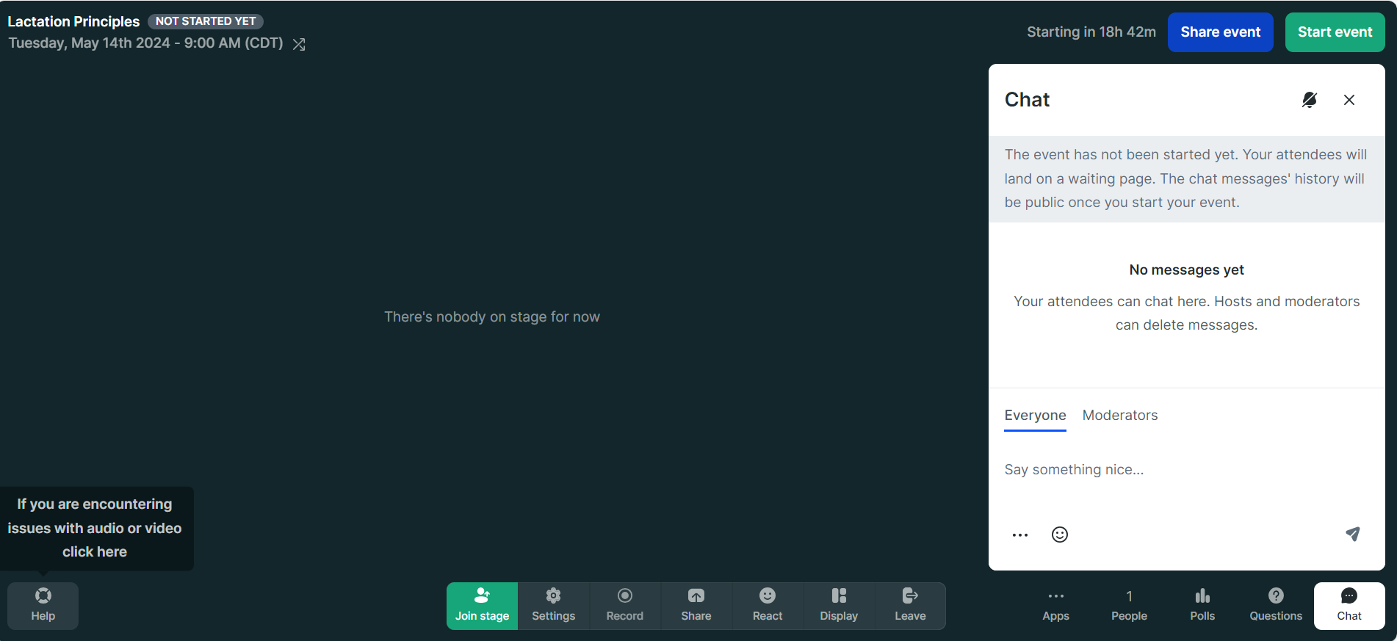

Directly above are the different tabs.

It could have text or just the graphics (bubble=chat, ?=questions)

When you click on one, it will be highlighted white as “Chat” is above.